TEACHER'S PROFILE
Department ofAnimal Biology named after N. O. Bazanov»

Personal data of the teacher
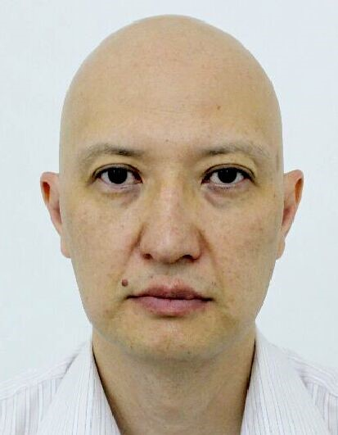 | Last name, First name, Patronymic (by ID card) |  |  |  |  |  | Sugirbaev Alim Fayzullayevich
 | Date of birth |  |  |  |  |  | 1975.05.11
 | Gender (male/female) |  |  |  |  |  | Husband
 | Nationality |  |  |  |  |  | Kazakh
 | Citizenship |  |  |  |  |  | of the Republic of Kazakhstan
 | Mobile phone, E-mail |  |  |  |  |  | +7 777263 4116  sugirbayev.alim@kaznaru.edu.kz.alim@kaznaru.edu.kz
Education
Higher educational institution
a) name |  | of
KazNAIU country, city |  | of Kazakhstan, Almaty
year of admission and graduation |  | 1992-1997
qualification obtained at  the end of the educational institution |  | Commodity specialist - engineer for animal raw
materials Academic degree and title (to date)
Academic degree |  | Candidate of Agricultural Sciences
Dissertation topic |  | Formation of the skin of young sheep of the South Kazakh merino breed in potsnatal ontogenesis
Branch of science |  | sheep
breeding Code of scientific specialty |  | 06.02.04
Specialty name |  | Private zootechnics; technology of animal products production
Year of defense |  | 2002
Dissertation language |  | Russian
Academic title
Scientific activity
Research performer in the Republic of Kazakhstan (within the last 3 years)
Title of research |  |  |  |  |  | Years |  |  | of implementation Implementing organization
Project of commercialization of RNNTD DP23692436 "Production of therapeutic and preventive products from mare's milk" |  |  |  |  |  | 2024-2026 |  |  | IP Turysbek Ayatkhan
PCF IRN BR24993222 "Building a decision support system for the natural and economic development of the territory of the North Kazakhstan region in the context of sustainable development" |  |  |  |  |  | 2024-2026 |  |  | Kazakh National Agrarian Research University
Scientific and pedagogical activity
Information about the number of publications for the last 3 years
Type of publications |  |  |  |  |  |  |  | Number
of Main scientific publications (for the last 3 years)
Publication Name |  |  | Author (s) |  | Year  of publication Publication name, volume, number, page
Patent / Innovation Patent
Assigned number |  | Title |  | Author/Patent |  |  |  |  |  | holder Date of issue and validity
period Foreign language proficiency
Language |  |  |  | Proficiency level (low, medium, high)
Russian |  |  |  | High
English |  |  |  | Medium

